**Impact of Population Change on Housing and Rental Price During COVID**

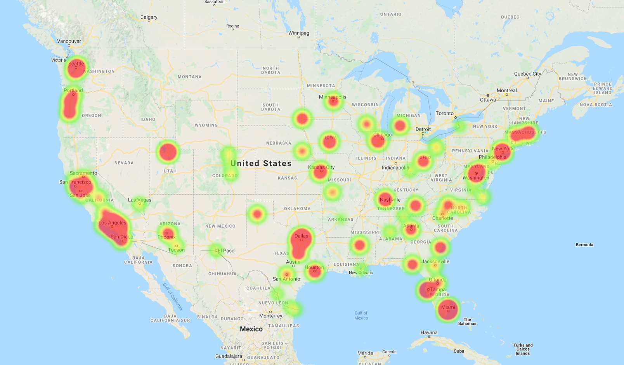

(Heatmap above represents all cities in the US with positive population growth between 2018-2020)

**Q1.** **Which cities across the United States experienced population changes due to pandemic COVID?**

To begin the analysis of population change during the COVID period, we examined the population in 2018, 2019 and 2020 (COVID era). We accounted for growth or decline in population by calculating the change in percentage from 2018-2019 and 2019-2020 as reported by the U.S. Census. Further, we found the difference between the two time periods to derive which cities had the largest growth or decline from 2018 to 2020. Refer to table on the left. 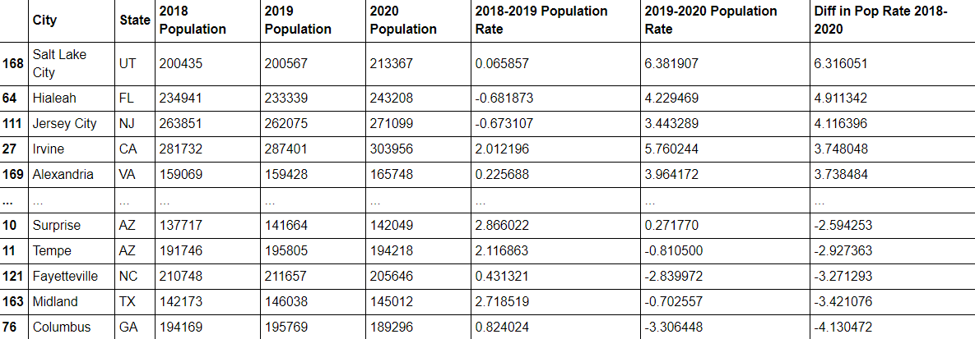

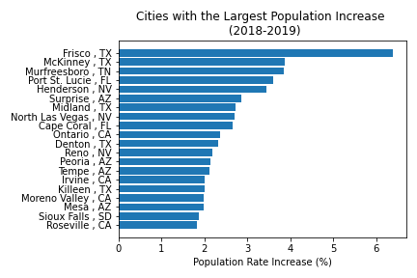 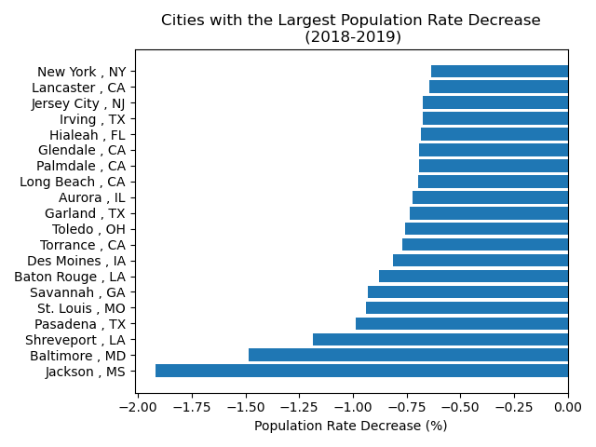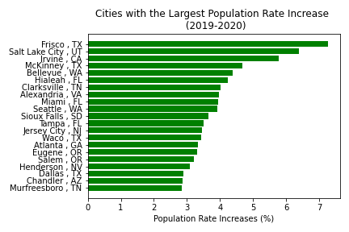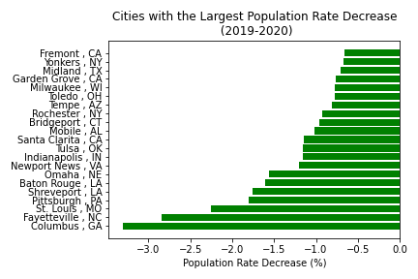

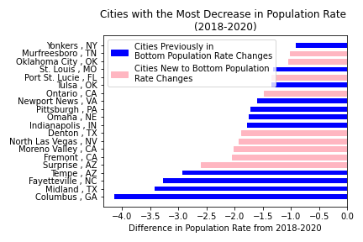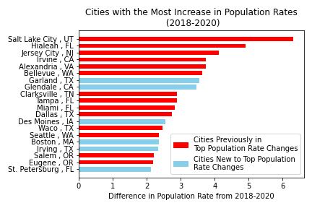

We identified the top and bottom 20 cities with the largest positive and negative population rates during each time period (2018-2019 and 2019-2020) and overall growth rate or decline for 2018-2020. From the figure representing 2018-2020, we see Salt Lake City experiencing the highest population growth rate and Columbus, GA experiencing the highest population decline. In comparison to the cities that made it to the top and bottom 20 lists in 2018 and 2019, six new cities (i.e. Garland TX, Glendale CA, Des Moines IA, Boston MA, Irving TX, and St Petersburg FL) appear over the time span 2018-2020. From this, it can be deduced that these cities were most affected by the pandemic in 2020 in drawing new residents. On the other hand, cities such as Surprise AZ, Moreno Valley CA, and Fremont CA had a larger growth decline rate when comparing pre-COVID to COVID periods, which reflects that residents were leaving these cities at a faster rate in 2020.

**Q2. How has the rate of housing price changed between the two periods (2018-2019) and (2019-2020)?**

We collected housing sales price data for 2018-2020 and plotted the rate of change for each year sorted for the top and bottom twenty cities from the population data.

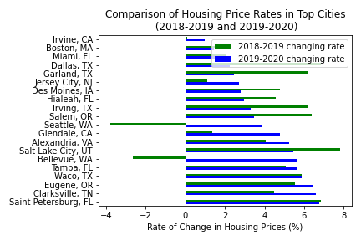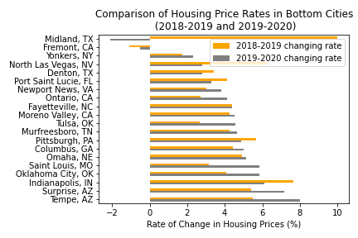

Of note, Seattle and Bellevue in Washington previously had a decrease in their housing sales price in 2018 to 2019 but have had a jump in their pricing from 2019 to 2020. This huge increase in rate could be a byproduct of the pandemic with residents purchasing homes that support their telecommuting arrangements in the setting of low interest rates, which make home ownership affordable and desirable. In comparing the 2018-2019 housing price rate with 2019-2020, most cities with high population growth rate have experienced an increase in housing prices. However, cities with declining population rates have inversely been stagnant or lost valuation in their housing prices.

We also plotted Atlanta, GA housing price trends over the past 2 years and saw that there was a stagnation of housing prices during the initial COVID lockdown period. It can be assumed that buyers were hesitant to view prospective homes to purchase due to fear of contracting COVID. However, around about May 2020, Atlanta sees a surge in housing prices which may be due to Georgia’s reopening and historically low interest rates.

In comparing Atlanta to a comparable housing market, such as Las Vegas, NV, we see similar housing trends pre and post COVID; although, Las Vegas saw a larger decline in the housing market prior to COVID.

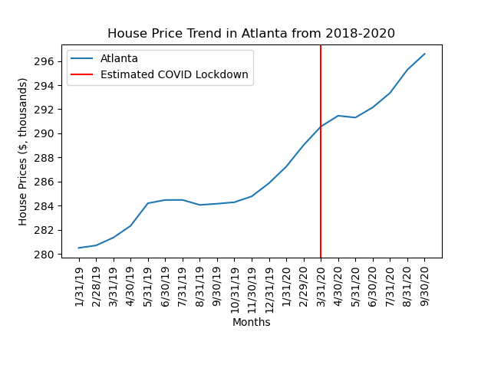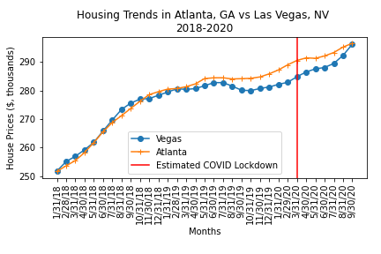

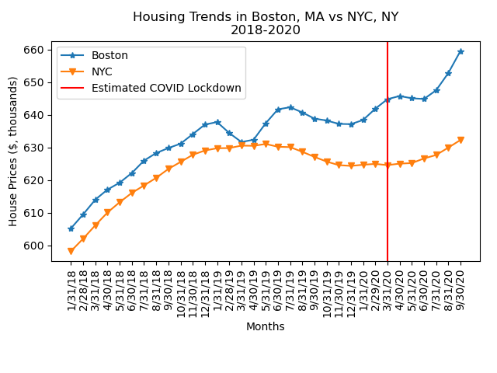

We further examined the housing trends in a higher priced housing market, specifically NYC and Boston, where similar patterns emerged. It is interesting to note that NYC has had a slower recovery since COVID lockdown possibly due being severely impacted by the cases of COVID which led to a prolonged lockdown period.

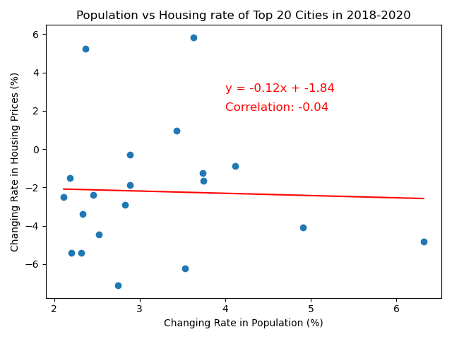

**Q3: Is there a correlation between the population change rate and the housing market rate?**

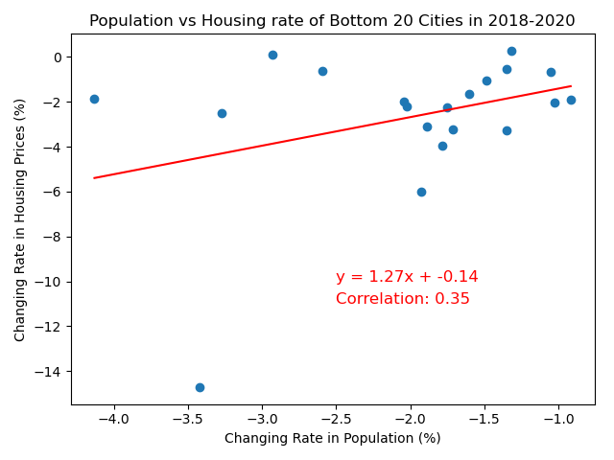To look for a correlation between the population vs housing market rate, we continued analyzing the top and bottom 20 cities with the largest population changes against their housing market changes. Our theory was to see a strong correlation between changes in population on the housing market. We plotted population vs housing market rate changes from 2018 to 2020 for the top 20 cities, there is actually a slight negative rate of change (i.e. as a city grows in population, the housing prices see a small decrease in pricing.) Bottom 20 cities reflected a decrease in housing price rates in relation to a larger decline in population rate. This plot shows that the demand in houses decreased when more residents moved to other cities, thus lowering the housing prices. Contrary, there is no correlation for the top 20 cities. This analysis may be limited/not reflective due to a low amount of census data in 2020, which likely inhibited sufficient comparison to the housing data.

**Q4: How has the rate of rental prices changed throughout 2018 to 2020 in certain metropolitan areas due to COVID?**

****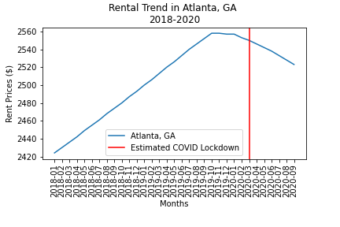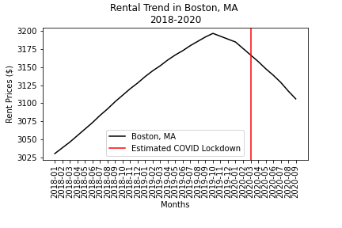

We examined rental market trends from 2018 to 2020 for Atlanta and Boston. The red line indicates COVID impact. There is an inverse relationship between the housing and rental market trends. Although the housing market grows after COVID lockdown, the rental market has a steep decline in prices uncharacteristic of the previous rental trends. We can deduce by these trend comparisons that previous renters are now purchasing homes post COVID lockdown which may be facilitated by the lower barriers of housing purchases or combining households or moving into the suburbs where homes are both more affordable and accommodating a household’s needs (schooling, bigger homes, outdoor space, tranquility, less congestion, etc).